Installation Guide

This installation guide serves as a written alternative to the Installation Guide video that can be reached from the playlist in the Videos directory.

To begin, download the CodeBlocksHTCVive and CodeBlocks Networking projects, [Unreal Engine 4](https://www.unrealengine.com/download), and [Microsoft Visual Studio 2015](https://www.visualstudio.com/thank-you-downloading-visual-studio/?sku=Community&rel=15).

Unreal Engine 4 must be downloaded and installed after installing the Epic Games Launcher.

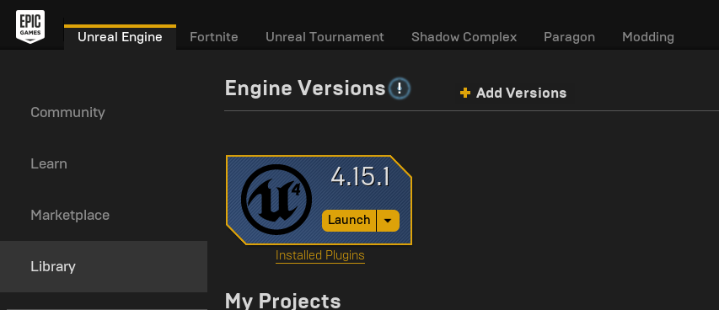

After the Epic Games Launcher is installed, open the Launcher and navigate to the Unreal Engine tab in the top left.

Next, click the Library tab on the left menu and install Unreal Engine 4.15.x (The x can be any number, as this version is always updated and replaced when a new version comes out.)

The download and installation will take around an hour, and requires user attention as an administrative prompt at the end can cause the installation to fail if not responded to in time.

After installation, click the Launch button under the Unreal Engine version installed in the Library tab.

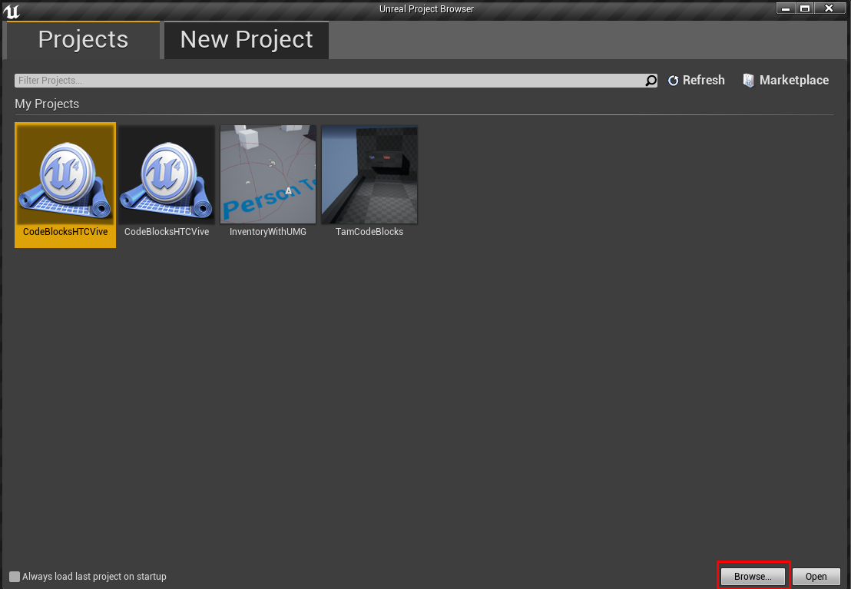

Click the Browse button in the bottom right of the new window, and navigate to the directory where the CodeBlocksHTCVive and projects were downloaded.

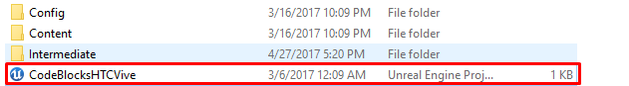

Open the project folder of the project you wish to run, and select the .uproject file in the directory to start the project.